Section Slides: <http://webdev.slides.com/coltsteele/mysql-99-101#/42>

Adding A Couple New Books

* For this section we will add a few new books to our table, to further illustrate the additional tools we’ll be learning
* Code summary

INSERT INTO books

(title, author_fname, author_lname, released_year, stock_quantity, pages)

VALUES ('10% Happier', 'Dan', 'Harris', 2014, 29, 256),

('fake_book', 'Freida', 'Harris', 2001, 287, 428),

('Lincoln In The Bardo', 'George', 'Saunders', 2017, 1000, 367);

SELECT title FROM books;

Using DISTINCT

* The **DISTINCT** function is used in conjunction with SELECT to return only distinct (unique) entries in a selection
* In our *books* table, some authors are present multiple times because they have more than one title in our table

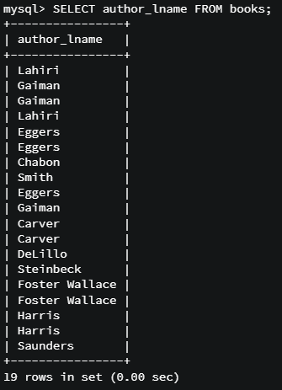

* + If we just want unique author last names, we use SELECT **DISTINCT**.

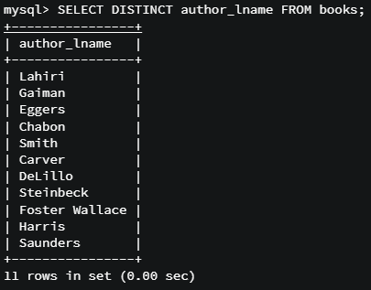

* Another example, where we select the distinct years of publication. This example shows how this function works with integers/numbers in addition to strings

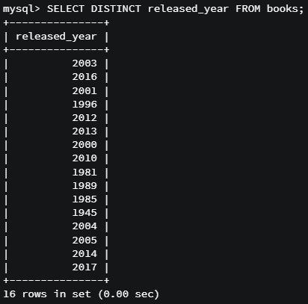

* An advanced topic, there are two authors with the last name “Harris” in our table.



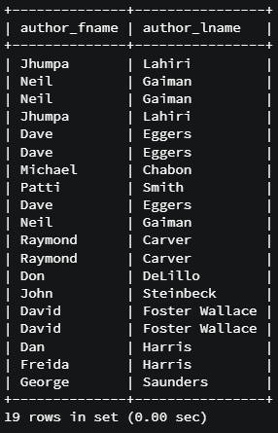

* + If we were to select last names only, we would only get one “Harris” back because they are the same last night
  + But what if we wanted distinct FULL names? Can we combine two columns and have the method resolve distinctions among them? Yes, we can!



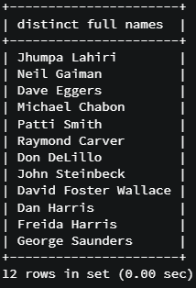

* Code summary

SELECT author_lname FROM books;

SELECT DISTINCT author_lname FROM books;

SELECT author_fname, author_lname FROM books;

SELECT DISTINCT CONCAT(author_fname,' ', author_lname) FROM books;

SELECT DISTINCT author_fname, author_lname FROM books;

Sorting Data with ORDER BY

* The **ORDER BY** function allows us to sort our data by specified criteria, perhaps in alphabetical order, or increasing or decreasing value
* Example: This sorts our data in alphabetical order by author last name
  + By default this is sorted in *ascending* order

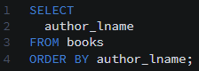

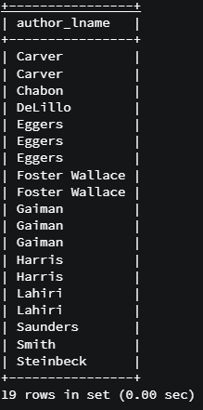

* Another example with titles, where we have both letters and numbers in our titles (though they are all VARCHAR)

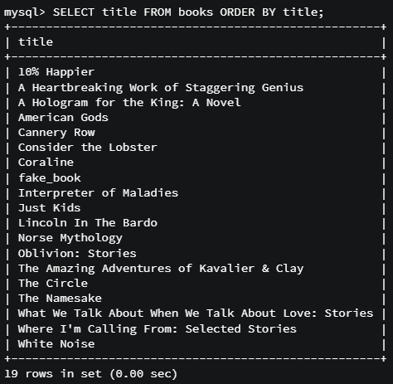

* + Notice how the numbers come before letters in alphabetical order
* We can change the order to *descending* by adding **DESC** to the end of the query

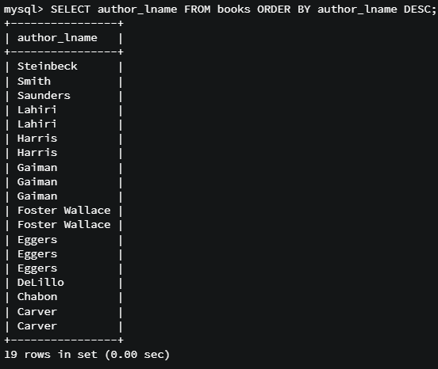

* Sorting, obviously, works numerically as well

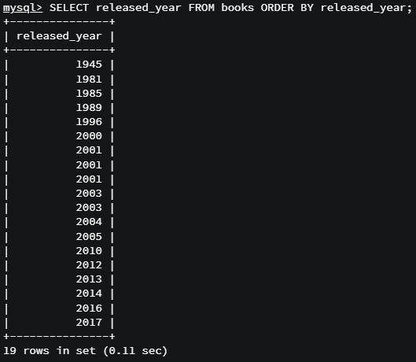

* We don’t have to order by the property that we’re selecting. We can select multiple properties (columns) for our data that are ordered by one of those properties (column), or even by the property that you’re not selecting
  + For example, in our books table we can select the title, released year, and pages, ordered by released year

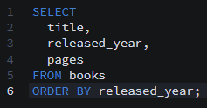

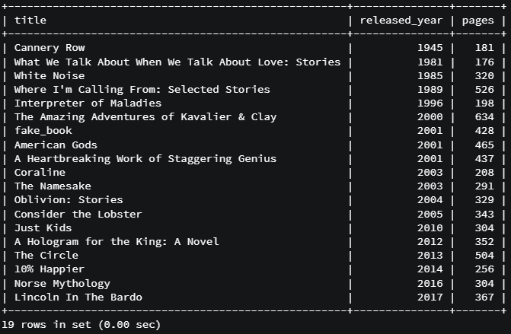

* + We can even leave the selection for released_year out entirely, but still order by it

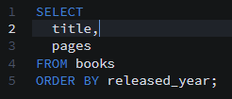

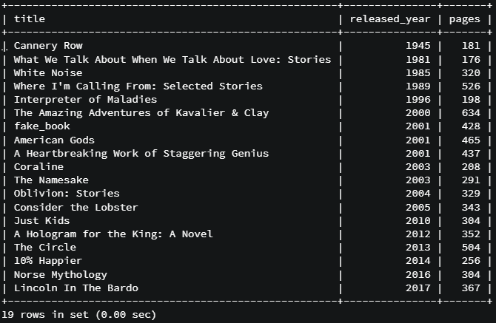

* A quirk to consider – take a look at this query. Here, **ORDER BY 2** is simply a shortcut indicating that we want to order by the second property that we’re selecting by.

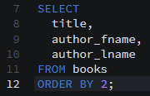

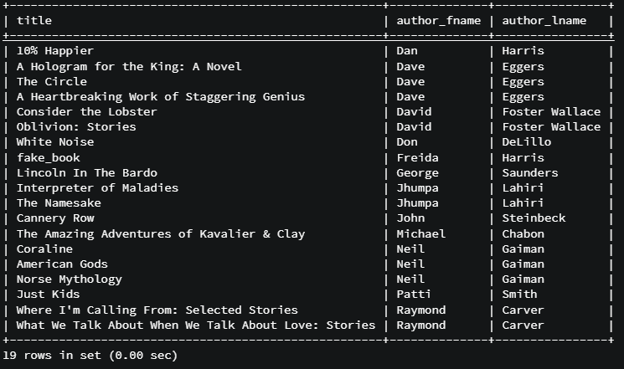

* + We can easily change this to a different property by just changing the number

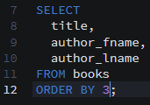

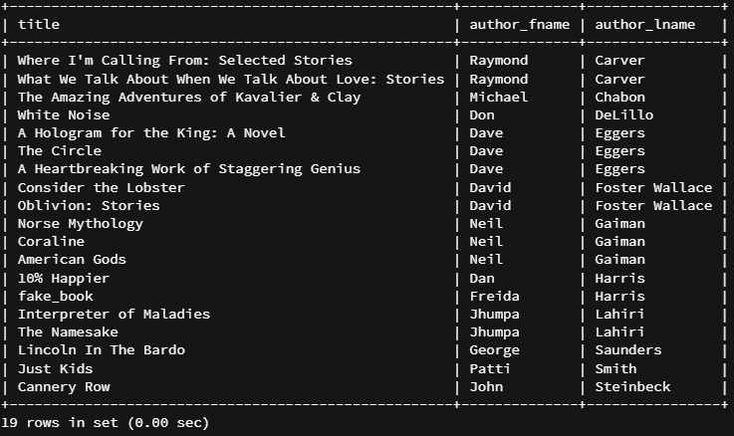

* + Order matters here – the order by number is agnostic to the actual property that it is sorting by. If you declare the selections in a different order, then it will select the property in that position
* What about **ordering by multiple columns?** This is something that is done, albeit relatively infrequently. In this example, the names will be sorted first by author last name, then by author first name
  + In this particular example, notice how Dan Harris and Freida Harris share the same last name. However, with this dual sorting, Dan will be listed before Freida since “D” comes before “F” in the alphabet

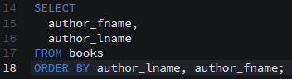

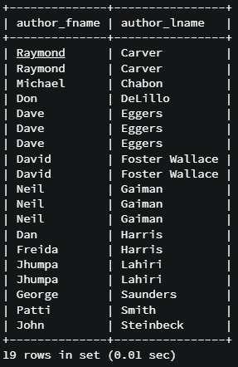

* Code summary: ORDER BY

SELECT author_lname FROM books;

SELECT author_lname FROM books ORDER BY author_lname;

SELECT title FROM books;

SELECT title FROM books ORDER BY title;

SELECT author_lname FROM books ORDER BY author_lname DESC;

SELECT released_year FROM books;

SELECT released_year FROM books ORDER BY released_year;

SELECT released_year FROM books ORDER BY released_year DESC;

SELECT released_year FROM books ORDER BY released_year ASC;

SELECT title, released_year, pages FROM books ORDER BY released_year;

SELECT title, pages FROM books ORDER BY released_year;

SELECT title, author_fname, author_lname

FROM books ORDER BY 2;

SELECT title, author_fname, author_lname

FROM books ORDER BY 3;

SELECT title, author_fname, author_lname

FROM books ORDER BY 1;

SELECT title, author_fname, author_lname

FROM books ORDER BY 1 DESC;

SELECT author_lname, title

FROM books ORDER BY 2;

SELECT author_fname, author_lname FROM books

ORDER BY author_lname, author_fname;

Using LIMIT

* The **LIMIT** modifier allows us to specify the number of results that we want to select. By default, a selection will include all rows that meet the selection criteria
* Example from our *books* table, where we select only the first 3 entries
  + The LIMIT modifier will display the “first 3” whether they are sorted or not



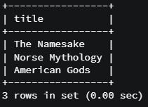

* LIMIT becomes much more useful when used alongside sorting via ORDER BY
* In this example, we want the 5 most recently-released books, in descending order. We can do the following

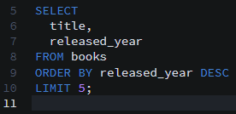

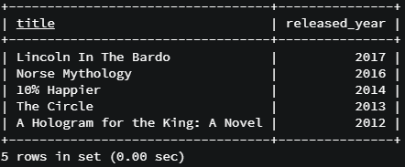

* Another use case is to specify the starting point of your selection limit, followed by how many items you want to list starting from there. In the code below, we want to start from the first (zeroth) row and list five rows of data. It functionally does the same thing as our previous example above.
  + Notice how the indexing of rows is different from the indexing of strings. In MySQL, row indexes start at 0, while string indexes start at 1.



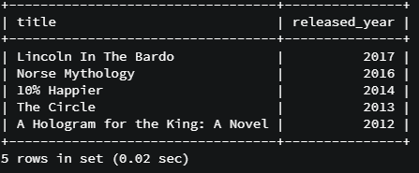

* + Another example using different limits:



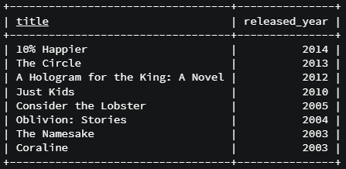

* + An uncommon use case is to identify an exact row by using a range of 1. The example below will simply give us the 11th row (indexed at position 10) as follows:



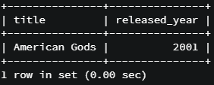

* There is not elegant way to specify that you want to select all the way to the end of the table. Instead, you have to use a large number for the second parameter:
  + Basic syntax: **SELECT * FROM tbl LIMIT 95,18446744073709551615;**
  + Example:





* Code summary, LIMIT

SELECT title FROM books LIMIT 3;

SELECT title FROM books LIMIT 1;

SELECT title FROM books LIMIT 10;

SELECT * FROM books LIMIT 1;

SELECT title, released_year FROM books

ORDER BY released_year DESC LIMIT 5;

SELECT title, released_year FROM books

ORDER BY released_year DESC LIMIT 1;

SELECT title, released_year FROM books

ORDER BY released_year DESC LIMIT 14;

SELECT title, released_year FROM books

ORDER BY released_year DESC LIMIT 0,5;

SELECT title, released_year FROM books

ORDER BY released_year DESC LIMIT 0,3;

SELECT title, released_year FROM books

ORDER BY released_year DESC LIMIT 1,3;

SELECT title, released_year FROM books

ORDER BY released_year DESC LIMIT 10,1;

SELECT * FROM tbl LIMIT 95,18446744073709551615;

SELECT title FROM books LIMIT 5;

SELECT title FROM books LIMIT 5, 123219476457;

SELECT title FROM books LIMIT 5, 50;